Re-analysis of the AL data from the included systematic reviews and meta-analyses.

**Chunwen Chen et al. (2021)**

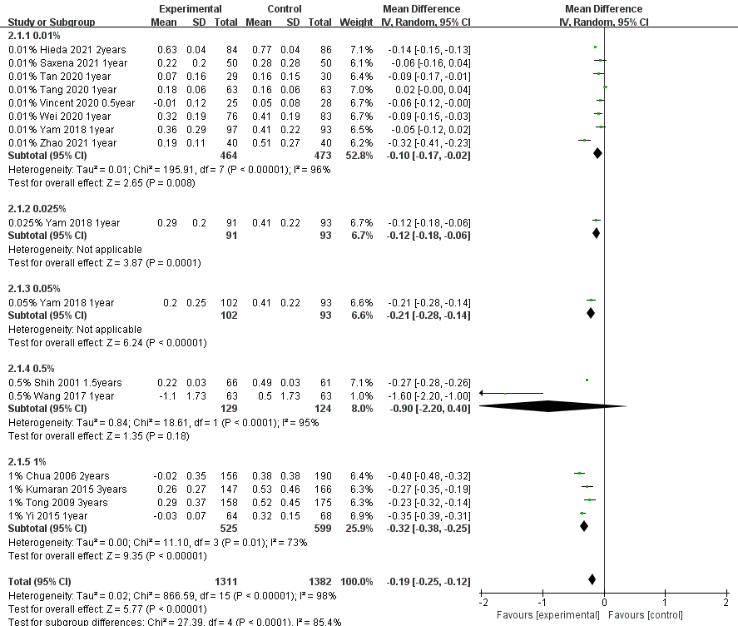

**Jiahe Gan et al. (2022)**

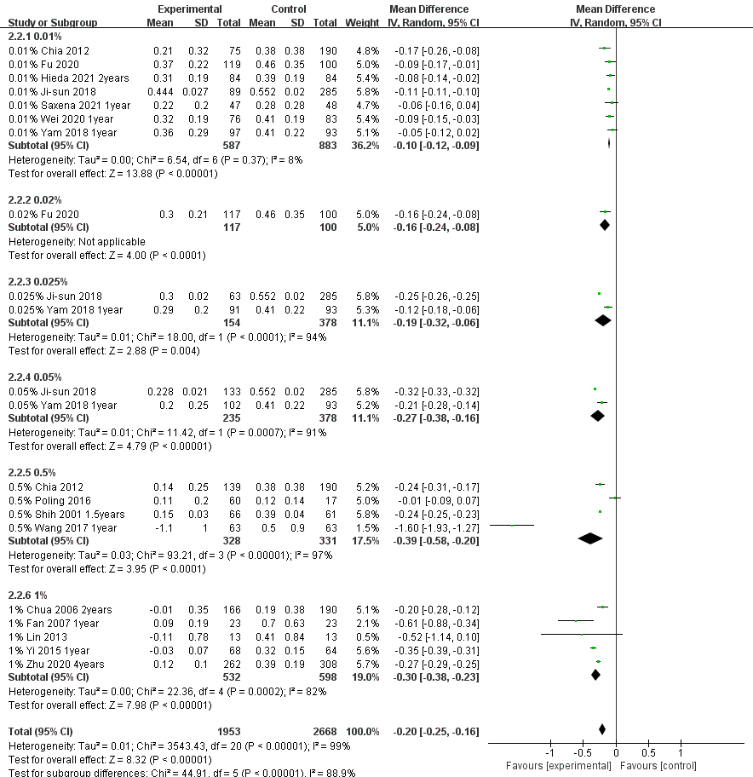

**Qianwen Gong et al. (2017)**

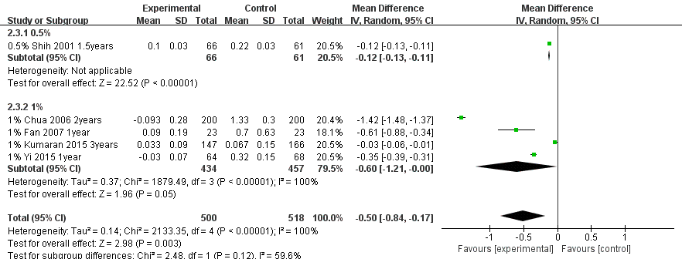

**Carla Lance et al. (2023)**

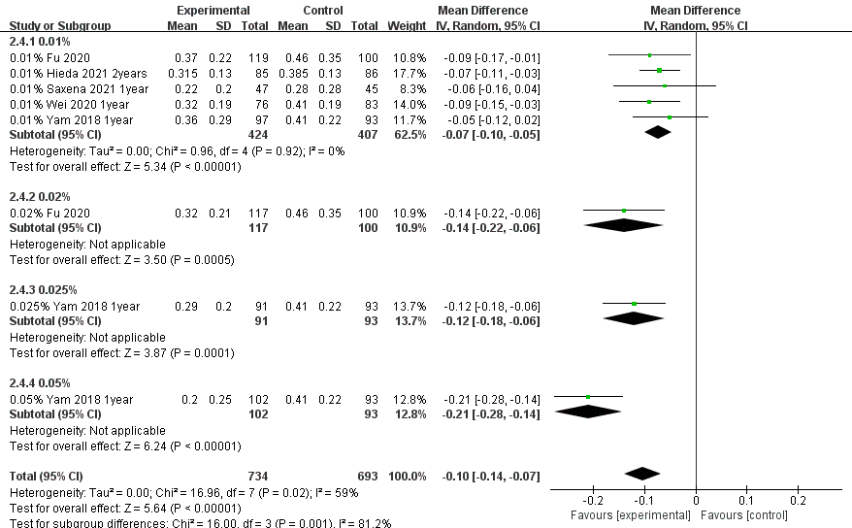

**Huy D M Tran et al. (2021)**

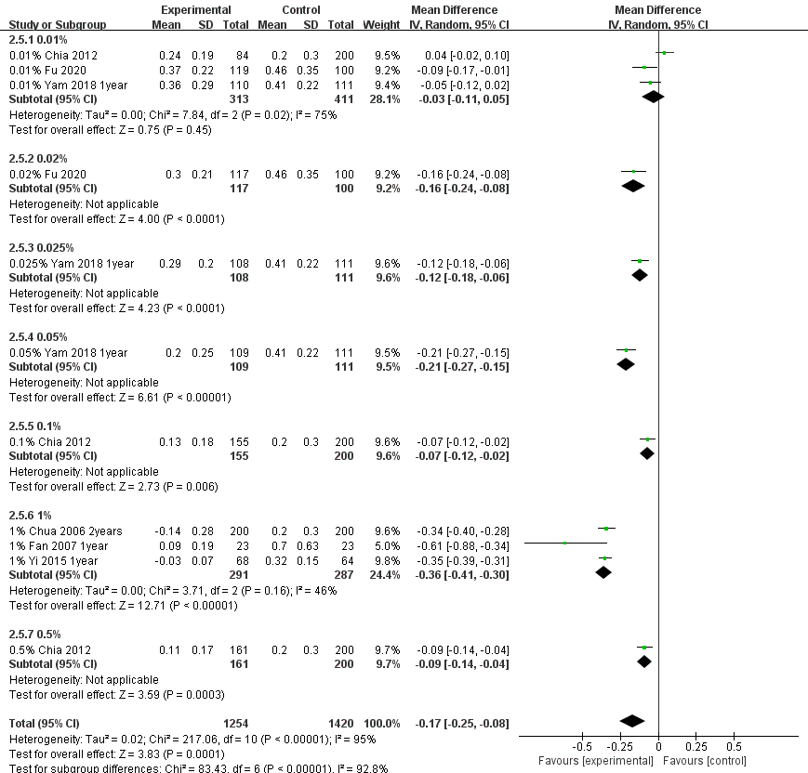

**Suzhen Wang et al. (2020)**

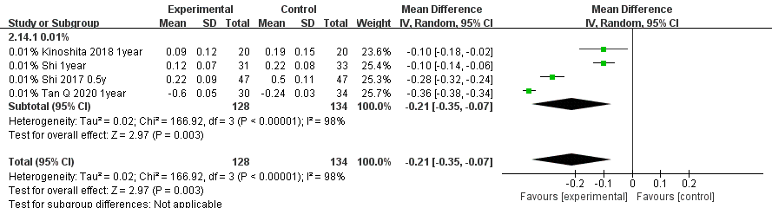

**Ning Yang et al. (2022)**

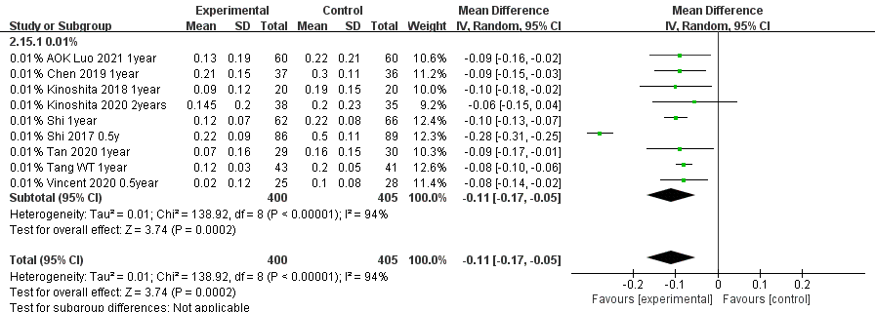

**Congling Zhao et al. (2020)**

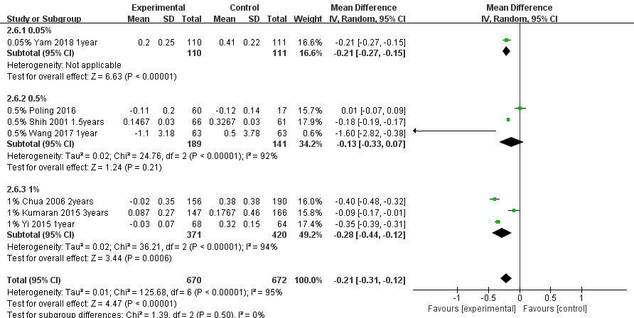

**Ningning Zheng et al. (2022)**

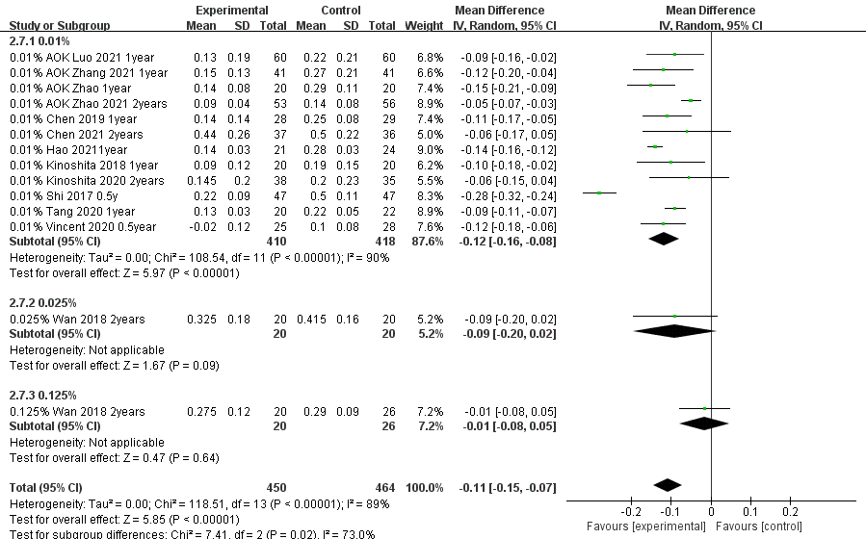

**Canran Gao et al. (2021) (Figure downloaded from the article of Canran Gao)**

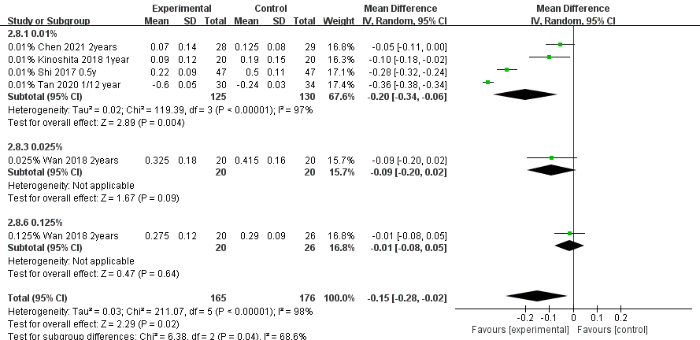

**Xinli Wei et al. (2023)**

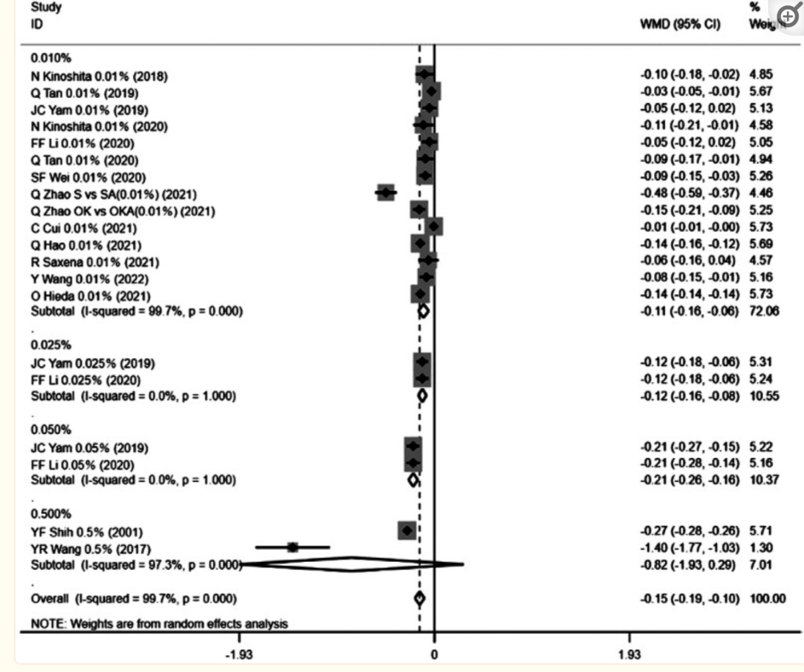

**Zengying Wang et al. (2023)**

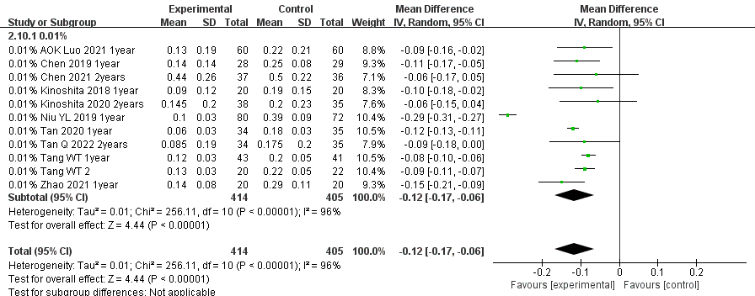

**Houren Tsai et al. (2021)**

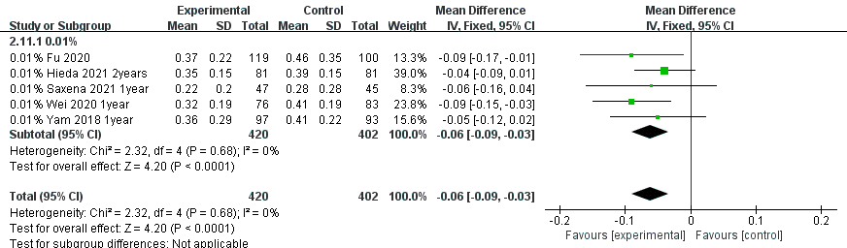

**Weiying Sun et al. (2022)**

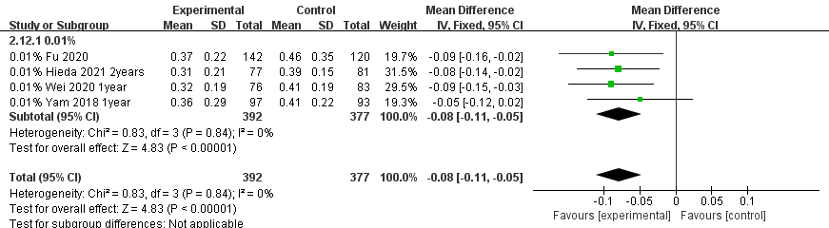

**Shalini Kumari et al. (2022)**

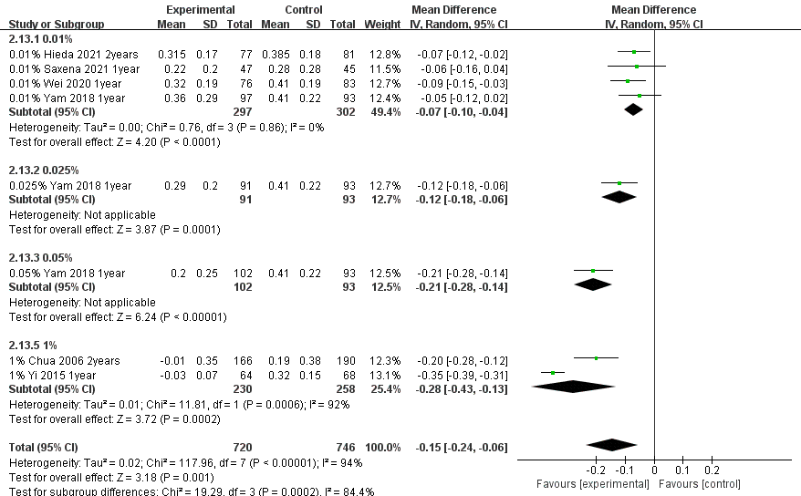

**Haobo Fan et al. (2022)**

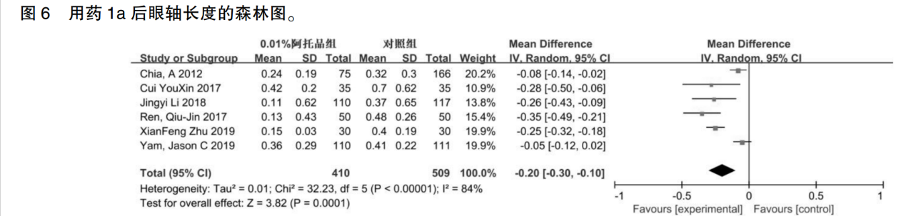

**Meng Zhang et al. (2022)**

